

TALGIL COMPUTING & CONTROL LTD.
NAAMAN CENTER, HAIFA - ACCO ROAD
ISRAEL
P.O. BOX 775 KIRYAT MOTZKIN 26119
TEL: 972-4-8775947 - 8775948
FAX: 972-4-8775949

SAPIR PC SOFTWARE

1999

GENERAL

The PC SAPIR software package enables the communication from a Personal Computer to the SAPIR controllers in the field. Any number of SAPIR controllers of various types can be connected to a personal computer via different communication channels to enable central control. Through the center, programs can be defined or updated, the irrigation process can be monitored, commands can be sent, events can be inspected and the water and fertilizer consumption can be accumulated and recorded.

REQUIREMENTS

The software is meant to run on IBM PC compatible computers under DOS (3.0 or above) operating system. Any version higher than 386 equipped with a color SVGA display, 2 Mbyte of memory a hard disk of 100 Mbyte and sufficient serial ports will do.

VARIOUS COMMUNICATION OPTIONS

3.1 Cable Communication

When a two wired communication line is being used, each SAPIR has to be added a small communication card, plugged into the main board. At the PC side a communication interface has to be connected to the proper COM port. Notice the polarity of the two wires, one is marked Positive and the other Negative. When the communication line is longer than a few meters, using of lightning protection for the two wires is recommended.

3.2 Telephone Modem

When the communication is based on the telephone lines, each SAPIR has to be added a modem interface and a low power modem, which will be connected between the interface and the telephone line that can be regular or cellular. When the cellular system is used, a special mobile phone for data communication supplies the connection to the telephone line. At the other end of the telephone line another modem is used to connect the PC to the line.

3.3 Radio communication

For radio communication a kit containing Receiver/ Transmitter + Antenna + Interface has to be installed both at the center and in the field near each Sapir unit. In some cases when there is an option to connect some SAPIR units together by a two wired communication line, then by using a special coordinating interface, a single Receiver/ Transmitter can serve the whole group.

GENERAL GUIDELINES

The intention of this manual is to lead the way into the PC SAPIR software. We shall describe the installation process and give the general guidelines for using it but we shall not go into too much deepness in the description that would end up with an encyclopedia that nobody will read. We believe that with the given guidelines the user can find his way easily by himself.

The recommended steps are as follows:

- Install the software as described in the next paragraph.
- Define the list of units that are going to be communicated by the software. Without having this list the software does not recognize the units and does not know how to communicate with them.
- Your main screen for checking the activities and for defining irrigation program will be the screen of FIELD UNIT OVERVIEW, here you can concentrate on a selected item, program each valve individually or all the valves together in a table form.
- Use the CYCLICAL COMMUNICATION REQUEST to define the rate of fetching information from the field units.
- Define the classification of your irrigation stations. Each station can be classified by the plot and by the crop it belongs to. Later, based on the accumulated information, daily, monthly and yearly reports per crop and per plot can be obtained.

INSTALLING THE SOFTWARE

The software is supplied along with a HASP plug without which the software will refuse to function. The HASP has to be plugged into the parallel port of the PC (the same one that is used for the printer). There are two types of software packages, one is good for communicating a single SAPIR unit and the other for communicating multiple SAPIR units, the protection HASP is not the same in both cases, make sure you have the correct one.

The software is generally supplied on a 3.5” diskette and it contains among the other files an “install” file to simplify the installation process. In the following discussion we suppose that the 3.5” diskettes drive in your system is called “A” otherwise replace the “A” with the correct letter. Now if you are inside “Windows” we suggest restarting the computer under DOS. Insert the diskette into the 3.5” drive and while having the DOS prompt write:

A:>INSTALL A: C: and hit the <ENTER> key.

As a result of the command above a new directory under the name “P_SAPIR” will be created and all the needed programs will be copied into it. A new batch file SAPIR.BAT will be added to the root directory enabling activation of the software just by typing “SAPIR” followed by <ENTER>. Make sure that the CONFIG.SYS file contains allocation of at least BUFFERS=40 and FILES=40.

When the installation is completed the software is started automatically revealing a welcoming screen. Hit the <ESC> key or wait a few seconds and the MAIN MENU appears:
Selected unit
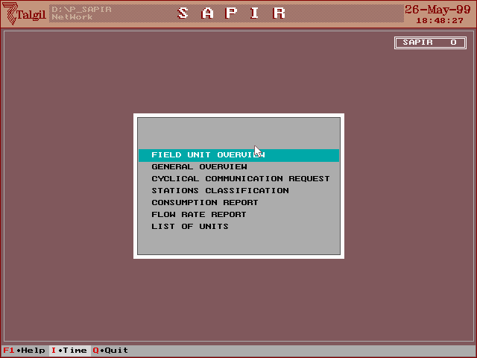
The selected subject pointed at by the selection bar. The bar can be moved either by mouse or by the arrows
Function bar, used for selection of special functions

USING THE MOUSE

- Use the mouse to point to the desired item.
- Use the left button to select the item. The function of the left button is similar to the function of the <ENTER> key.
- Use the right button to escape to the previous level like the <ESC> key.

USING THE <TAB>, <ENTER>, AND <ESC> KEYS

- <TAB> - The screens are divided into logical sections according to their function or according to the subject dealt with. The <TAB> key is used for moving from one section to another.
- <ENTER- The function of the <ENTER> key varies depending on the situation of the actual field: it can be used for selecting the item pointed at, it can be used for requesting permission to change the current field and it can serve for confirmation of the currently inserted value.
- <ESC>- The escape key is used for returning to the previous level. For example if we open a screen from the main menu or if we open a window from a sub menu the <ESC> key will close the last level and return to the former one.

THE OPTIONS OF THE MAIN MENU

The MAIN MANU shows a list of subjects available to the user.

- FIELD UNIT OVERVIEW

Supplies a colorful graphic picture of the selected unit and serves as the main screen for programming and controlling activities in that unit. The display shows all the items controlled by the unit and the color of each item indicates its status. In order to get more detailed information, Items can be selected and for each selected item windows are opened through which the user can see and change data.
Time and date at the
field unit
Graphic representation of the network to be controlled by the current unit
Automatic refresh time
Time and date at the PC
Battery level
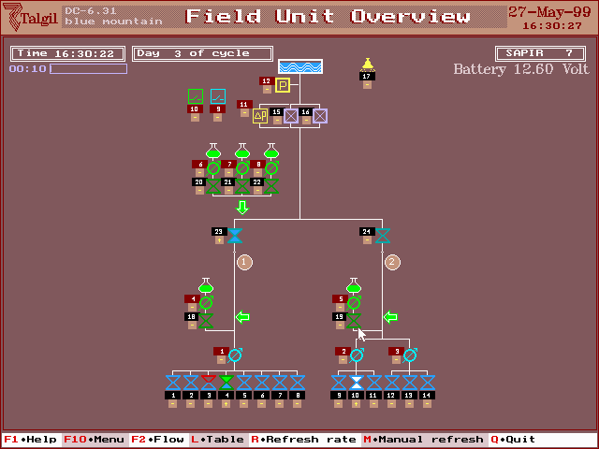
The color of the item represents its status. Use F1 to see the description
Each item can be selected in order to get more information,
change parameters,
or define programs
F10- Opens a sub menu
Concentrated table form information and
programming
Define the automatic refresh rate
F2-Adds flow
display to meters
Selected item
Current status of station 4
Water dosage section
Fert dosage section
Irrigation control section

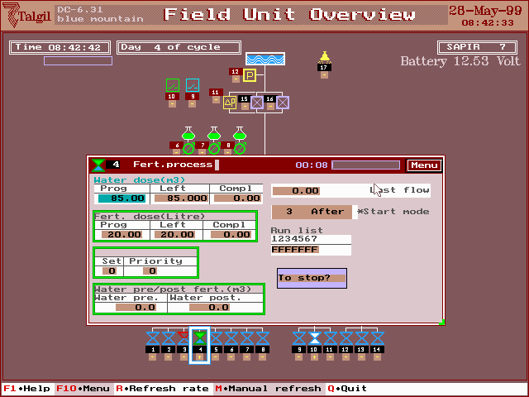
The following screen shows how the table form enables definition of the irrigation program of all the valves in one step. There is also an option of changing by % the water or fertilizer dosage of all the valves of a line.

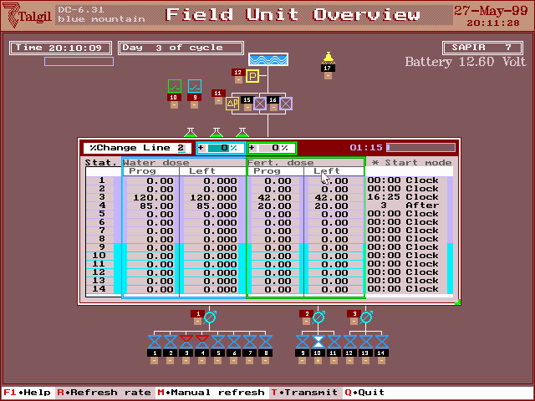
The line to be changed by %
The % of change for water (blue), fert (green)
Water dosage
Fert dosage
The
starting cause
- GENERAL OVERVIEW

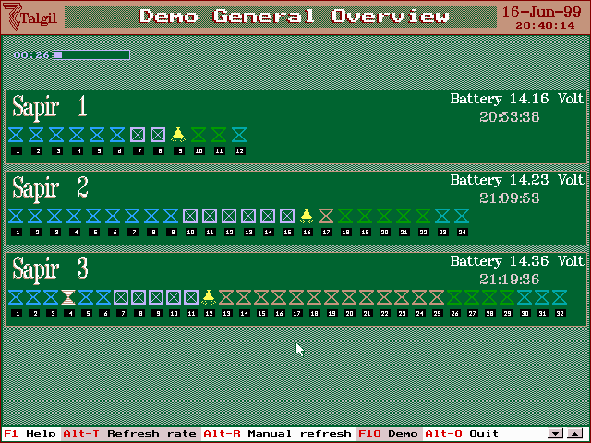
A general overview is given about the current status of all the units connected to the PC. The information per each unit appears in a horizontal raw in which all the output devices of that unit are displayed with the colors telling the status of the device.

- CYCLICAL COMMUNICATION REQUEST

The purpose of this screen is to allow definition of the rate by which selected information is fetched from the units in the field. This mechanism serves the events collection, the consumption recording and the flow monitoring systems.
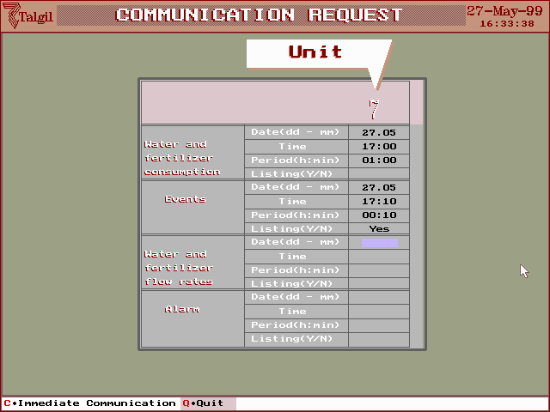
Events will be fetched every 10 minutes saved and printed. The next time will be on 27/5 at 17:10

- STATIONS CLASSIFICATION

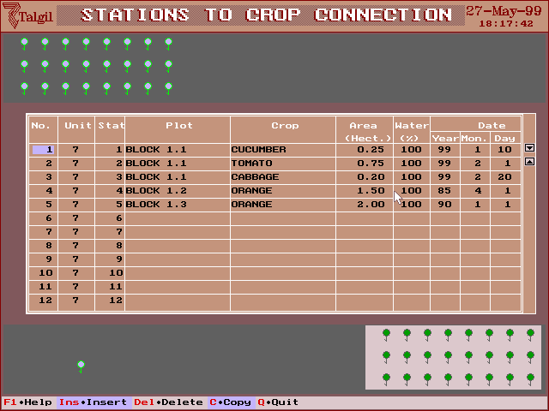
The irrigation stations can be classified to various classes according to the crops or the plots they belong to. Users that are interested can get the consumption report per each crop and each plot as explained in the next paragraph.

- CONSUMPTION REPORT

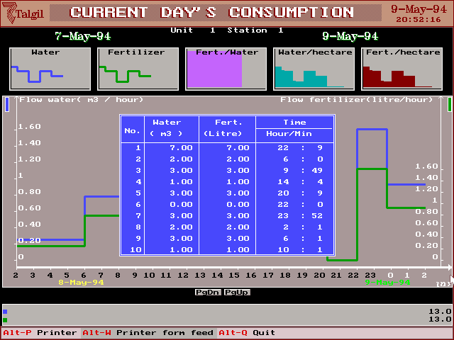

- FLOW RATE REPORT

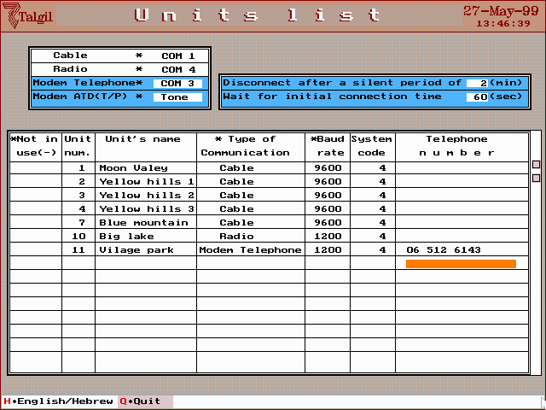
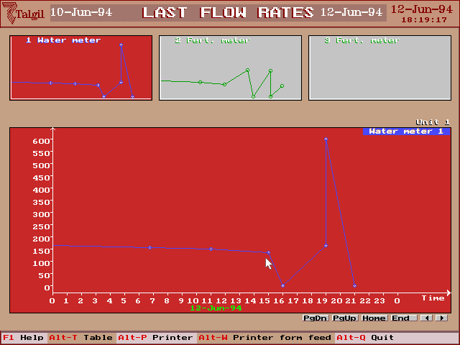
- LIST OF UNITS

Prior to any conversation with the SAPIR units in the field the software has to be defined the list of available units and the way each unit has to be contacted. Each SAPIR unit has two identification numbers (specified during the configuration process): One is its own personal number and the other is the number of the communication network it belongs to. Failing to define those two numbers correctly will eliminate communication with that unit. The screen above is used for defining the list of units. Notice that some of the units may be connected through direct communication Cable, some through Modem and some through Radio. When it is Modem communication, there are a few parameters to be defined and of course the phone number through which the unit should be called.

It is important to have the same baud rate defined both in the SAPIR and in the PC software, in Radio communication and Modem communication the baud rate should be set to 1200.

Units can be marked NOT IN USE by “-“ and then they will temporarily be out of reach.

Right after defining the list of units you MUST communicate at least one of the SAPIR controllers using the “FIELD UNIT OVERVIEW” dialog, only after doing that you will be able to use the other dialogs of the main menu.

SUMMARY

At this stage we hope that you installed the software successfully and started to get familiar with it. Remember that there is a HELP function that supplies important information about the software, it can be activated by F1. It has to be understood that most parts of the software depend on having good communication with the SAPIR units in the field, therefore the communication channels are of great importance and should be kept in good condition.

We wish you success in your work !

